Main messages and text modules

6.1 EPR

6.1.1. Brief explanation of the EPR

Headline:

Option 1: With the EPR, you can access your health data anywhere at any time.

Option 2: With the EPR, all treatment-relevant documents are in one place.

Short example:

The electronic patient record (EPR) is a digital collection of important information about your health. The EPR lets you view and store your medical data online. This means you and the health professionals you authorise can access important health information at any time.

Long example:

The electronic patient record (EPR) is a digital collection of important information about your health. This includes, for example, hospital and care reports on examination results, medication lists and the digital vaccination record. You can share this information easily and securely with the designated healthcare professionals. Thanks to the EPR, your medical data is always available and retrievable via a secure internet connection. This means you and the healthcare professionals you authorise can access important health information about you at any time.

6.1.2. Why do I need an EPR?

Short example:

With the EPR, your health data is:
- safe in one place
- available at all times
- immediately available in an emergency
You have full control over your health data

Long example:

The EPR lets you manage your health data yourself
- Control over your EPR: You decide who can access your health data
- Access to your health data: You and the authorised healthcare professionals can access your EPR at any time
- Immediately available in an emergency: In an emergency, vital information is immediately available
- Safe in one place: Your EPR is available at all times via a secure internet connection, and your health data is stored securely in Switzerland in compliance with data protection regulations.
- Better treatment quality and more patient safety are the main goals of the EPR. Improve the quality of your healthcare by setting up your EPR
- Appointment of EPR deputies: Share or delegate how your EPR is used

6.1.3. How the EPR works

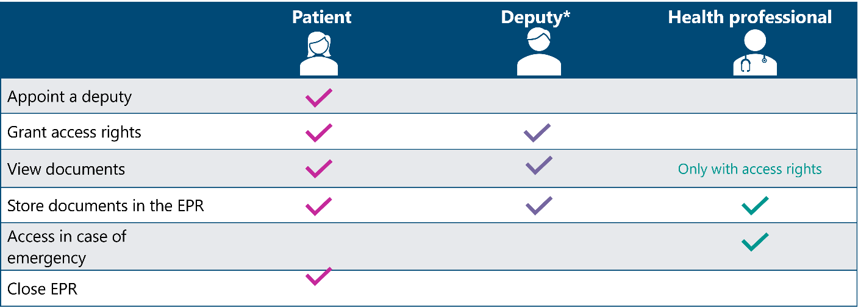

* You can grant access to your EPR to someone you trust. This person can help you manage your EPR partially or fully on your behalf.

6.1.4. How secure is the EPR?

Example:

Data protection and privacy are vitally important for the EPR. The EPR is subject to the Federal Act on the Electronic Patient Record (EPRA) and the Federal Act on Data Protection (FADP), which have strict rules on data protection and security. Sanela's EPR meets all these requirements. All data is stored in Switzerland. You will find more information about measures to protect your health data at patientendossier.ch.

6.2. Healthcare institutions offer the EPR

Individual headline:

Example 1: We are now connected to the EPR!

Example 2: [Name of healthcare institution] is now connected to the EPR!

Individual introduction

Example: With the electronic patient record (EPR), all relevant health data is available from a central and secure location. [name of healthcare institution] is also connected to the EPR. The EPR lets you access the relevant documents created during your stay at [name of healthcare institution] after your treatment.

Other external content for your healthcare institution’s EPR connection:

Do you already have an electronic patient record (EPR)?
Please inform your healthcare professional*. We will gladly upload the relevant documents to your EPR promptly** after your treatment.

Are the documents still not in your EPR after one week***?
If so, please contact test@gesundheitseinrichtung.ch***

Do you have any questions about the content of the treatment-relevant documents we have provided?
Please contact your healthcare professional

*In accordance with the healthcare institution’s internal process: Who in the healthcare institution should be informed?
** In accordance with the healthcare institution’s internal process: If the period for uploading documents to the EPR has been defined internally, the exact time can be shown.
*** In accordance with the healthcare institution’s internal process: Who can patients contact if the documents have not been uploaded to their EPR after a certain period?

Don’t yet have an EPR?

See also Section 6.3

Please give us access to your EPR
Would you like our healthcare professionals to have access to and be able to view your relevant health data? If so, please give us the corresponding access rights. You can find us in your EPR at: NAME OF HEALTHCARE INSTITUTION*.

Do you have any questions about access rights?
If so, please go to patientendossier.ch. It explains access rights in detail.

*Name of healthcare institution as listed in the Health Provider Directory HPD – national directory of healthcare institutions, groups of healthcare professionals and healthcare professionals connected with the EPR. You can also include the listed groups and healthcare professionals as needed.

Do you have any questions about your EPR?
If so, please call Sanela on 0800 55 88 02 or send an email to support.sanela@post.ch.
Availability (except public holidays): Monday–Friday, 7:00 a.m. – 7 p.m., Saturday, 07.30 a.m. – 1 p.m

Further links that can be included:
You will find more information about your EPR on post-sanela.ch.

You will find general information about the EPR on the official platform patientendossier.ch for the electronic patient record (EPR) of eHealth Suisse, the federal government and the cantons.

6.3. Setting up an EPR

Headline:

Option 1: Set up your EPR – irrespective of when and where
Option 2: Set up your EPR – anytime, anywhere
Option 3: Set up your EPR – completely digitally

Short example:

Set up your EPR now – completely digitally

Have the following ready when you set up your EPR digitally:
- Your biometric passport or identity card (Switzerland or EU/EEA; exception: German ID card
- Your smartphone

You’re all set: Click here to set up your EPR now.

Please note: You must be at least 18 years old to set up an EPR digitally. If you are under 18, visit the website post-sanela.ch to learn how to set up your EPR.

You will find more information about setting up an EPR digitally here.

Other links to include:

You will find more information about your EPR on post-sanela.ch.
You will find general information about the EPR on the official platform patientendossier.ch for the electronic patient record (EPR) of eHealth Suisse, the federal government and the cantons.

Medium example:

Set up your EPR now – completely digitally in three steps:
- Create your verified electronic identity (eID) with SwissID if you do not already have one.
- You apply for your EPR from Post Sanela Health Ltd.
- You will receive a one-time, initial login for your EPR – done!

Have the following ready when you set up your EPR digitally:
- Your biometric passport or identity card (Switzerland or EU/EEA; exception: German ID card
- Your smartphone

Get started now

Please note: You must be at least 18 years old to set up an EPR digitally. If you are under 18, visit the website post-sanela.ch to learn how to set up your EPR.

You will find more information about setting up an EPR digitally here.

Other links to include:

You will find more information about your EPR on post-sanela.ch.

You will find general information about the EPR on the official platform patientendossier.ch for the electronic patient record (EPR) of eHealth Suisse, the federal government and the cantons.

Long example:

Set up your EPR now – completely digitally in three steps:

- Create your verified electronic identity (eID) with SwissID if you do not already have one.
- You apply for your EPR from Post Sanela Health Ltd.
- You will receive a one-time, initial login for your EPR – done!

It will take about 20-30 minutes to set up the EPR digitally. It will take a bit longer if you first have to open or complete a SwissID account.

Have the following ready when you set up your EPR digitally:

- Your biometric passport or identity card (Switzerland or EU/EEA; exception: German ID card)
- Your smartphone
- Access to your personal, active email account
- Login for your SwissID account and the SwissID app installed on your smartphone (latest version)

If you are under the age of 18 or have a custodian, the legal representative must set up the EPR. Please visit post-sanela.ch to learn how to set up your EPR.

Recommendation:
- Use your computer or tablet to set up the EPR:
Start setting up the EPR on your computer or tablet and use your smartphone for the steps in the SwissID app. You can also complete all the steps on your smartphone.
- Use of passport for identification:
Use your passport to verify your electronic identity. Your ID card is checked manually if you use it to authenticate yourself. You will be notified by email as soon as you can continue with the online set-up.

Get started now

Other links to include:

You will find more information about your EPR on post-sanela.ch.

You will find general information about the EPR on the official platform patientendossier.ch for the electronic patient record (EPR) of eHealth Suisse, the federal government and the cantons.

